

**AWS Deployment User Guide**

# Versioning History

|  |  |  |
| --- | --- | --- |
| **Date** | **Changes Made** | **Done By** |
| 24/08/2017 | 1. Introduction 2. Prepare production codes 3. Deployment to AWS S3 (front-end) 4. Deployment to Tomcat Server (Back-end) | Sheryl Chong |
| 29/08/2017 | 1. Updated prepare codes for front end for aws s3 connection for admin-portal | Sheryl Chong |
| 20/11/2017 | 1. Putty connection 2. Database connection 3. Run Create and Insert Statement in Database | Sheryl Chong |

Table of Contents

Versioning History 2

Introduction 4

Prepare Production Codes 4

Front-end codes – legit-app 4

Front-end codes – admin-portal 4

Back-end codes 5

Deploying the codes 5

Front-end 5

Back-end 6

# Introduction

This document will guide you on how to deploy our application codes to the AWS Server. We will be deploying the front-end codes to the S3 server and back-end codes to Tomcat server.

# Prepare Production Codes

## Front-end codes – legit-app

1. Navigate to the config.component.ts file in legit-app / admin-portal folder
2. Change the environment to production

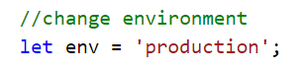

1. Save the file
2. Open CMD / Terminal at Visual Code Studio
3. Change directory to our project folder (legit-app / admin-portal)
4. Enter “ng build –prod –aot=false”

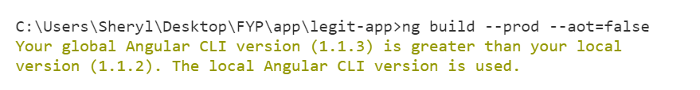

1. After the code run successfully, a dist file will be created.

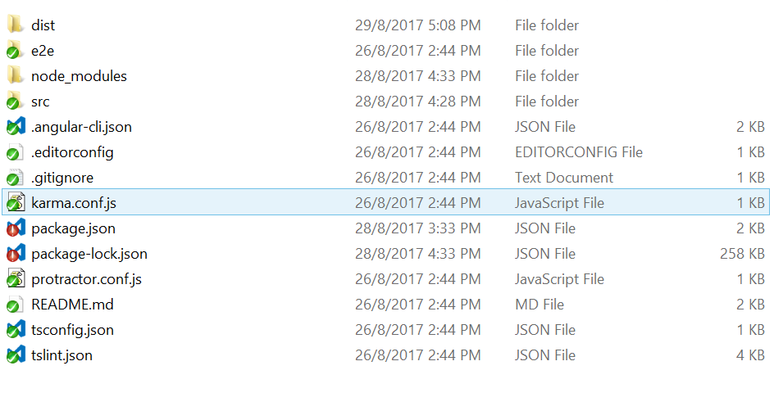

## Front-end codes – admin-portal

1. Navigate to the config.component.ts file in legit-app / admin-portal folder
2. Change the environment to production



1. Navigate to pattern-details-add.component.ts in the pattern-details-add folder
2. Add the access key in 2 parameters (AWSService.config.accessKeyId , AWSService.config.secretAccessKey)

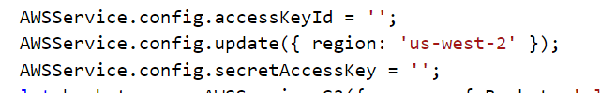

1. Save the files
2. Open CMD / Terminal at Visual Code Studio
3. Change directory to our project folder (legit-app / admin-portal)
4. Enter “ng build –prod –aot=false”



1. After the code run successfully, a dist file will be created.



## Back-end codes

1. Start your NetBeans
2. Open our backend NetBeans project
3. Insert aws db password in the backend
   1. Expand Source Packages
   2. Expand database
   3. Click on “connection.properties”
   4. Key in the access key for “aws.db.password”
   5. Save the file

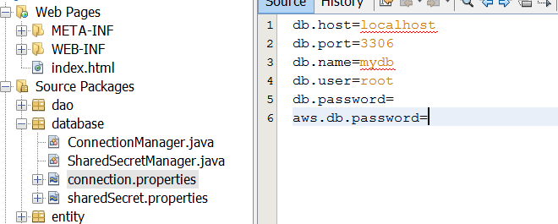

1. Click on “Clean and Build”
2. Click on “Run Project”
3. A dist folder will be created. In the dist folder, a war file is created as well.

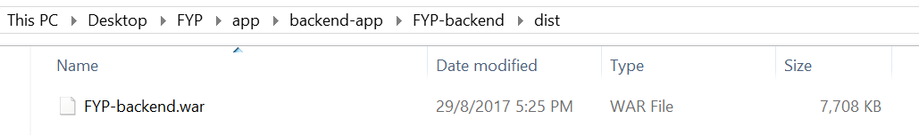

# Deploying the codes

## Front-end

1. Login to AWS account
2. Click on “Service” at the top left-hand corner
3. Click on “S3” to navigate to S3 service
4. Click on “highlander-app” if you are deploying the front-end for the ecommerce website. Click on “highlander-admin” if you are deploying the front-end for the admin portal.
5. Click on upload button

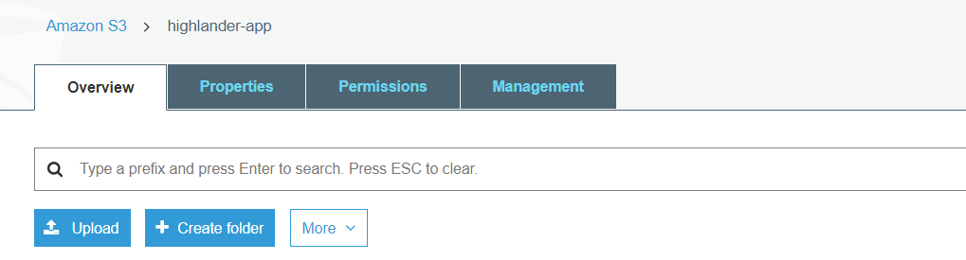

1. Click on add files button

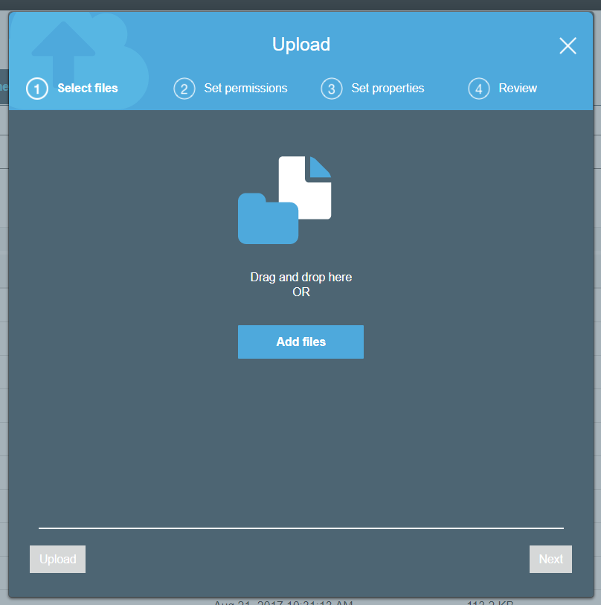

1. Navigate to dist folder of legit-app/admin-portal Click on open button
2. Select all the files and click on open button
3. Click on upload button
4. Click on the assets folder in the s3 folder
5. Click on the image subfolder
6. Click on upload button
7. Navigate to dist folder of legit-app/admin-portal and click on the asset folder
8. Select all the files and click on open button
9. Click on upload button
10. All the files required for deployment are uploaded!

## Back-end

1. Go to EC2 URL provided by the group
2. Enter the username and password
3. Click on “Undeploy” for FYP-backend
4. Deploy the new war file
   1. Click on “choose file”

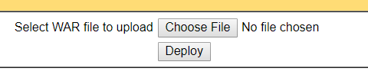

* 1. Select the war file in the dist folder of the FYP-backend
  2. Click on open button
  3. Click on deploy button



# Database Connection

## Connection to database via putty

1. Run putty.exe
2. Key in the following details

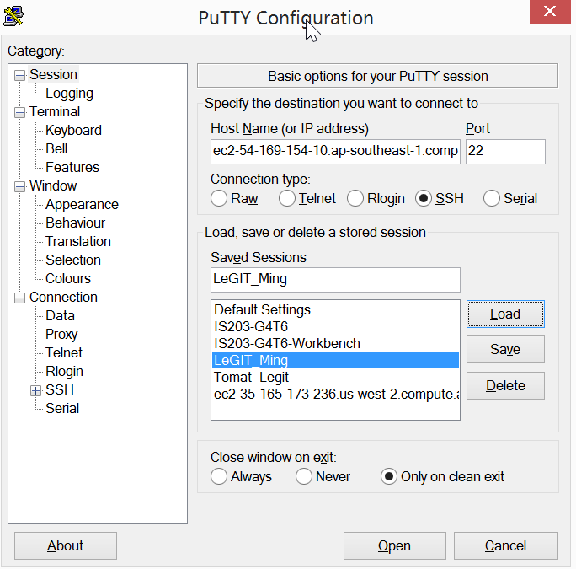

|  |  |
| --- | --- |
| **Field Name** | **Data that you need to input** |
| Host Name | Public DNS (IPv4) from AWS  ec2-54-169-154-10.ap-southeast-1.compute.amazonaws.com |
| Port | 22 |
| Connection Type | SSH |

1. Insert public key for authentication

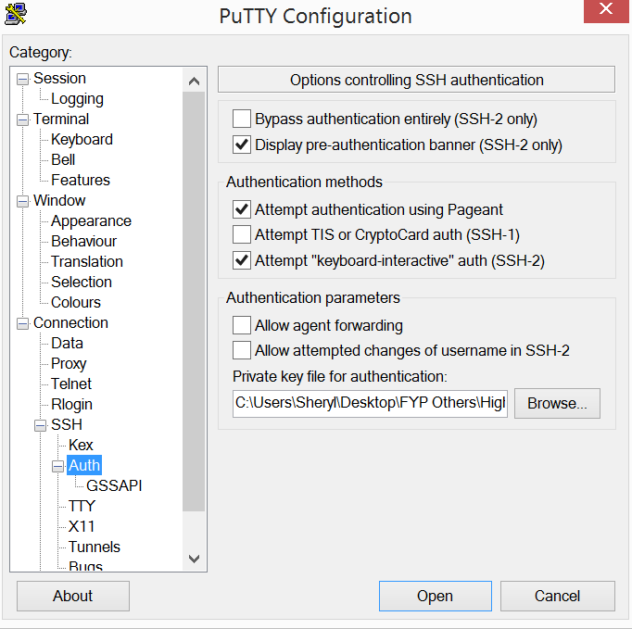

1. Click on “open”
2. A window will pop up
   1. Login as : bitnami
   2. Passphrase: h1ghlander

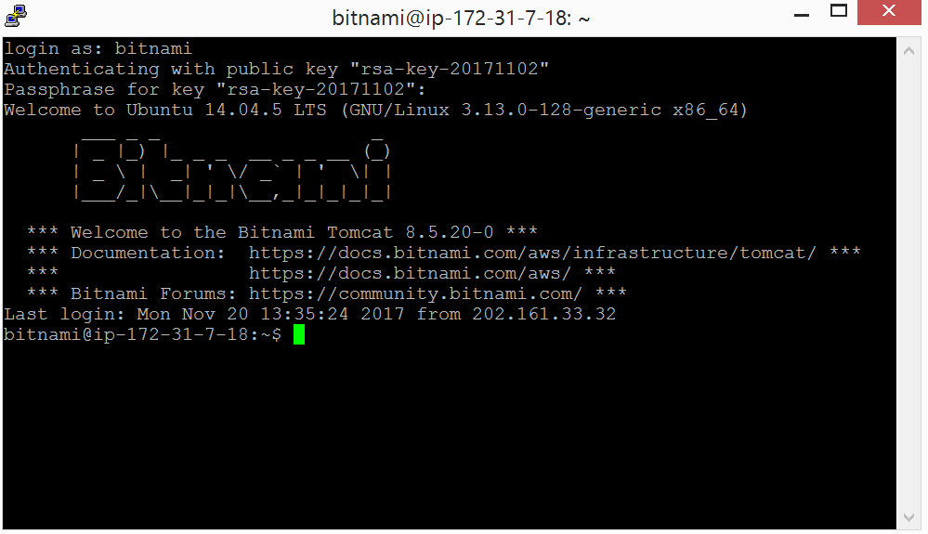

## Navigating to Server’s database

1. after connecting to the server via putty, access the server’s database via <http://localhost:8888/phpmyadmin/>
2. key in the details to login
   1. username: **root**
   2. password: **bMgMY5PcnByK**
3. click on “mydb” at the left-hand side

## Running create and insert statement

1. After navigating to the database
2. click on “Import” at the top navigation bar
3. choose your file to import for the server to run the SQL statement